1. Create one VPC,with 1 one public subnet and 1 private subnet

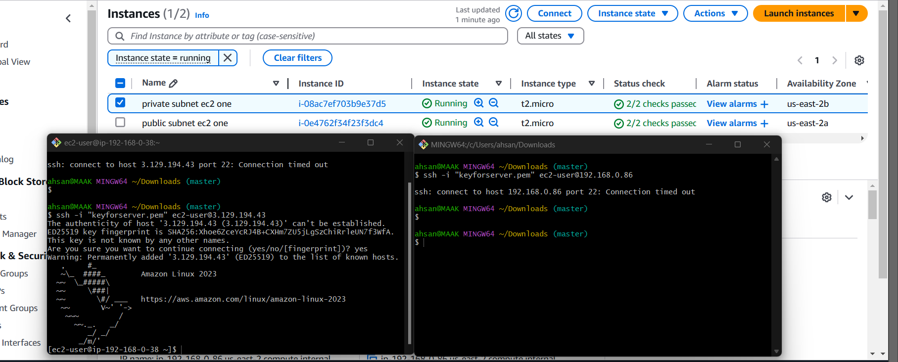

1. Enable VPC peering for cross region.

